LEP – Sub Committee

LEP - Lancashire Skills and Employment Board

Private and Confidential: NO

Wednesday, 29 November 2017

Update from the Lancashire Skills & Employment Hub
Appendix A refers

Report Author: Dr M Lawty-Jones, Director of the Lancashire Skills Hub, Michele.Lawty-Jones@lancashirelep.co.uk

Executive Summary

This paper provides an overview of Lancashire Skills & Employment Hub activity since the last committee meeting.

Recommendation

The Skills & Employment Board are asked to:

- Note the update.

1. Careers Education, Information, Advice and Guidance (CEIAG)
  - The Lancashire Enterprise Adviser Network with Inspira has grown from 78 schools and colleges at the end of September to 97 mid-November. Of the 97, 85 have been matched with at least one volunteer business leader (Enterprise Adviser). 89 initial diagnostics have been completed and 77 development plans are either in place or have been started. A wide range of activities are underway in each of the schools and colleges which are connecting local businesses with young people.

  - Press coverage is being planned for the 100th sign up with SKV. This will include reference to the broader network and case studies in local areas to maximise publicity in the local newspapers across Lancashire.

  - In relation to the Blackpool Opportunity Area, the Skills Hub is working with Blackpool Council to take forward Priority 3: 'Improve Advice and support for young people when moving between schools/colleges and into work'. A Priority 3 Delivery Group has been established and has met for the first time – this brings together the key delivery organisations responsible for taking forward the different activities referenced in the Blackpool OA Delivery Plan, which was published in September:
https://www.gov.uk/government/uploads/system/uploads/attachment_data/file/658581/Social_Mobility_Delivery_Plan_Blackpool_v6__FINAL_.pdf
Key is coordination and maximising impact by bringing activities together to provide a coherent, planned approach across primary, secondary and post-16 education.

  - All 13 of the secondary schools (including the special schools and the pupil referral unit) and colleges in Blackpool are engaged in the Lancashire Enterprise Adviser Network, and are matched with local business leaders. This includes Westinghouse UK, the Royal Bank of Scotland, Hilton Hotel Group, Hays Recruitment, Department of Work and Pensions (DWP), Blackpool Transport, The Winter Gardens, Baxter Life Care, Blackpool Football Club Community Trust and several micro-businesses/sole traders. All of the initial diagnostics have been undertaken and each now has a development plan. The Enterprise Coordinator, Andrew Heydeman has a key role in coordinating activity with employers and with organisations delivering activities which involve employer interaction.

  - A range of activities are being initiated, including the activities funded by the Careers and Enterprise Company. Direct employer activities are developing, for example, visits to the construction site of the new Police HQ in Blackpool with Willmott Dixon and employer talks to groups of young people about the range of construction-related careers available to them, and site visits to the Westinghouse Springfield plant and an insight into the range of career opportunities in the nuclear industry and energy sector more generally.

  - Work continues with National Careers Service (NCS). The CPD/LMI Energy Workshop hosted at Energy HQ, referenced in the last update was delivered on the 7th November and attracted 16 teachers, tutors and careers professionals from across the Fylde Coast. Inputs included tutors from Energy HQ and Fairbanks (fuel management specialists). Feedback received was excellent. A Digital workshop will take place before Christmas in Preston.

2. European Structural Investment Funds (ESIF)
2.1 In terms of the Priority 2.2. Skills for Growth call and the Priority 2.1 Skills for Growth call for Leadership and Management, we are awaiting feedback on the appraisals of the stage 2 and stage 1 applications submitted respectively. We are still awaiting confirmation from DWP in regard to timescales!
2.2 The Investment Priority 2.1 Skills for Growth call relating to Widening Participation, which was issued in 2016, has been reappraised following the failure of the bid submitted to pass the DWP gateway. The specification has been reviewed and positioned to focus on widening participation and underemployment. The revised specification has now been issued on the gov.uk portal and the deadline for Stage 1 applications is the 8th December – the call can be accessed via the following link: https://www.gov.uk/european-structural-investment-funds/lancashire-widening-participation-oc19s17p0912 An input was provided with Sean McGrath at a workshop involving the North West Universities European Unit, The Lancashire Colleges and a number of Lancashire-based universities and colleges to discuss the positioning of the call and technical aspects.
2.3 The ESFA is undertaking a scoping exercise with LEPs in relation to potential extensions to projects currently contracted under the ESFA opt-in. An email was issued to board members outlining the options and the response submitted to the ESFA, based on previous discussions at the board meeting. This will be discussed further under the dedicated agenda item.
3. National Young Apprenticeship Ambassador Network Launch
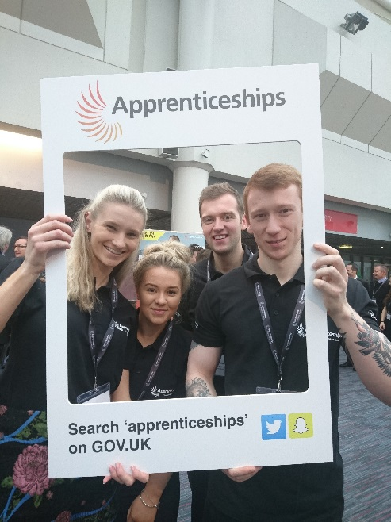
3.1 The launch of the National Young Apprenticeship Ambassador Network (YAAN) took place on Thursday 16th November at the Skills Show at the NEC. The National YAAN was launched by the Minister of State for Skills and Apprenticeships, the Rt Hon Anne Milton.
3.2 Along with Lisa and Sam Connelly from the Lancashire WBL Executive Forum, four of our Apprenticeship Ambassadors Board members came to the launch to represent Lancashire
L-R: Portia Taylor-Black, West Lancs Council; Alisha Clarkson from North Lancs Training Group; Oliver Crookham from North Lancs Training Group and Danny Blake from Trak Rap (Skelmersdale).
3.3 The room was teeming and there was a vibrant atmosphere at the launch event. We have now made good links with the North West employer and young ambassador networks, and as we evidenced strong partnership work happening on the ground in Lancashire, the North West network has requested that Lancashire share best practise and lead the way using our approach.
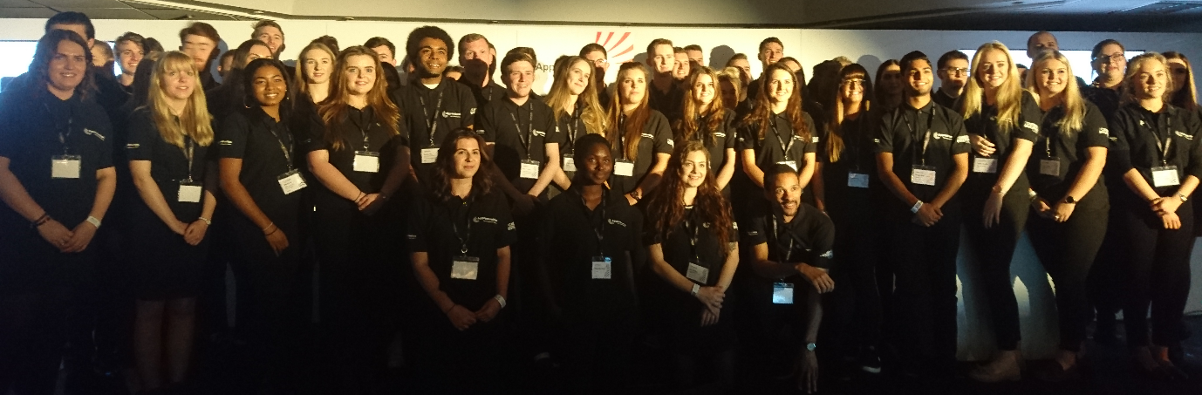

4. City Deal
4.1 The City Deal Skills and Employment Steering Group are presenting the City Deal skills and employment monitoring report which includes metrics for academic year 2016/17 and a case study dashboard, to the City Deal Executive on Wednesday 29 November. Please see Appendix A to see both the skills and employment section of the wider City Deal monitoring report and the dashboard.
5. Events
5.1 Following on from the Visitor Economy skills and employment workshop which the Skills and Employment Hub delivered in partnership with Marketing Lancashire, Lisa was invited to the Visit Lancashire members meeting on the 15th November and presented to approximately 40 delegates from the Visitor Economy sector to inform them of what support is currently available and to gain feedback. Daniel Rich, General Manager at Barton Grange, also presented and talked about why he has engaged with the role of Enterprise Adviser. The support available was well received and the Hub and partners are following up interest from several business.
5.2 The Hub sponsored the Apprentice of the Year category at the Sub 36 Awards 2017 (previously branded the Young 'Uns). The calibre of entries was excellent – the final shortlisted four who pitched to the judging panel exceeded expectation! Joanne Pickering gave the award on the night to the overall winner, Will Holmes from the Printed Cup Company – see below.
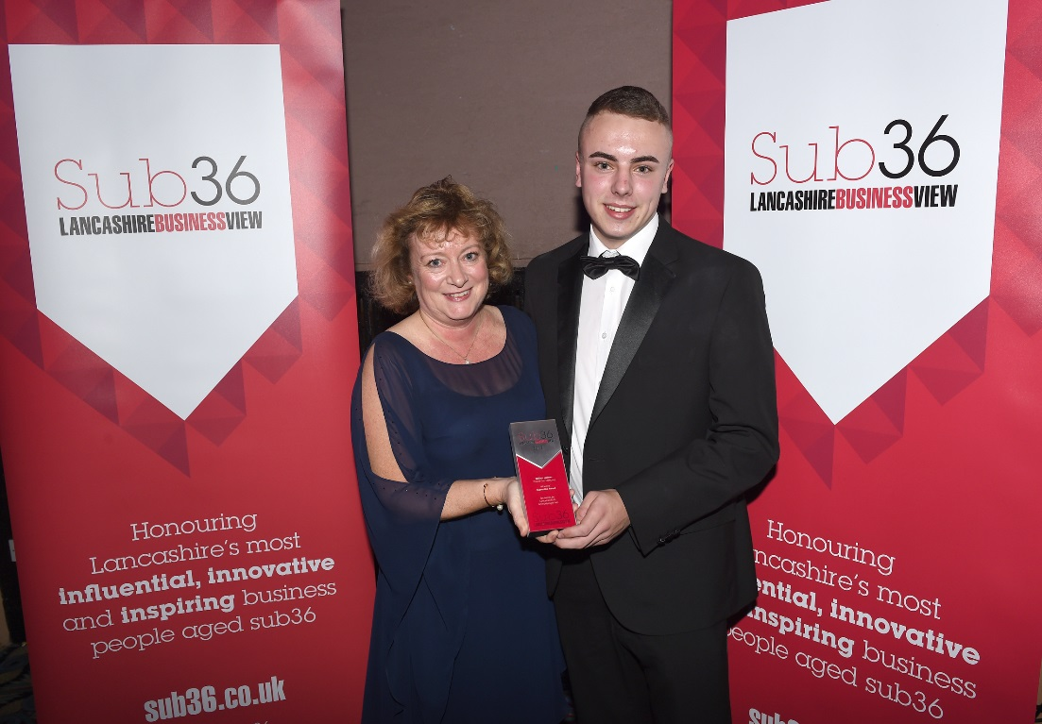

5.3 The Hub attended a workshop led by the Northern Powerhouse Partnership (NPP) with LEPs and Combined Authorities from across the North West to contribute to an emerging piece of work relating to education and skills priorities across the NPP area. Emerging priorities include school improvement and closing the disadvantage gap, as well as careers information, advice and guidance, and leadership and management. The Hub also sat on a panel with the NPP to gather evidence of what works from third sector organisations.
6. Technical Education – Visioning Piece
6.1 As discussed at the last committee meeting a Technical Education visioning piece has been commissioned. We have commissioned a company called SDG Economic Development (SDG-ED) to work with us to develop a clear vision for a high performing technical education system in Lancashire. The vision will encapsulate Lancashire’s future ambitions for technical education, identify objectives and priorities and suggest pragmatic recommendations for action, which are shared and owned by stakeholders.
6.2 The visioning piece will take into account the national policy context, the forecast labour market demands in Lancashire's priority sectors, current and emerging physical learning assets and future ambitions of providers based in the Lancashire area.
6.3 Stakeholder engagement is a critical element of this visioning piece. The process recommended by SDG-ED is iterative and involves a number of stages involving one-to-one stakeholder consultation and workshops.
6.4 The first workshop took place on Friday 20th October. There were 25 attendees, including 11 employers / employer representatives. Over 20 telephone interviews have also taken place with a mix of stakeholders, including schools, colleges, universities, independent training providers, employer representatives and employers. The second workshop is taking place on Thursday 23rd November; 38 were registered at the time of writing the report.
6.5 SDG-ED will be presenting the draft of the visioning piece at the committee meeting for committee members' review.
7. ABR Implementation Group
7.1 The ABR Implementation Group is scheduled to meet on Friday 24th November – a verbal update will be provided at the meeting. The collaborative action plan discussed at the last committee meeting has been amended in accordance with feedback from the committee and will be discussed further by the Implementation Group on the 24th.

